
Course Name and Code: Data Structures Lab (ITL302)
Semester: III (Second Year)
Academic Year: 2023-24 (Odd Semester)

Experiment No. 08

Aim: Implementation of any one Sorting Technique considering a real-world application.

Objectives:
1 To impart knowledge of sorting and searching algorithms.

Theory;
Sorting algorithm is used to arrange the elements of a list in a certain order (either ascending or descending). Searching any element in a huge data set becomes easy. We can use Binary search method for search if we have sorted data. So, Sorting become important here.

Types of sorting:

Selection sort is another sorting technique in which we find the minimum element in every iteration and place it in the array beginning from the first index. Thus, a selection sort also gets divided into a sorted and unsorted subarray.

Bubble Sort is the simplest sorting algorithm that works by repeatedly swapping the adjacent elements if they are in the wrong order. This algorithm is not suitable for large data sets as its average and worst-case time complexity is quite high.

Insertion sort is a simple sorting algorithm that works similarly to the way you sort playing cards in your hands. The array is virtually split into a sorted and an unsorted part. Values from the unsorted part are picked and placed at the correct position in the sorted part.
The Merge Sort algorithm is a sorting algorithm that is based on the Divide and Conquers paradigm. In this algorithm, the array is initially divided into two equal halves and then they are combined in a sorted manner.
Quicksort is a sorting algorithm based on the divide and conquer approach where an array is divided into subarrays by selecting a pivot element (element selected from the array).

Algorithm of selection sort:

1.Start with the first element as the initial position
- Find the smallest element in the unsorted portion of the array.
- Swap this smallest element with the first unsorted element.
- Move the boundary of the sorted portion one element forward.
- Repeat steps 2-4 for the remaining unsorted elements until the entire array is sorted.

Program:
#include <stdio.h>
#include <stdlib.h>

int smallest(int arr[], int k, int n);

void selection_sort(int arr[], int n);
void main(int argc, char *argv[])
{
int arr[10], i, n;
printf("\n Enter the number of elements in the array: ");
scanf("%d", &n);
printf("\n Enter the elements of the array: ");
for(i=0;i<n;i++) { scanf("%d", &arr[i]); }
selection_sort(arr, n);
printf("\n The sorted array is: \n");
for(i=0;i<n;i++) printf(" %d\t", arr[i]);
}
int smallest(int arr[], int k, int n)
{ int pos = k, small=arr[k], i;
for(i=k+1;i<n;i++)
{
if(arr[i]< small)
{ small = arr[i]; pos = i; }
}
return pos;
}
void selection_sort(int arr[],int n)
{
int k,
pos,
temp;
for(k=0;k<n;k++)
{
pos = smallest(arr, k, n);
temp = arr[k];
arr[k] = arr[pos];
arr[pos] = temp;
}
}

Output:
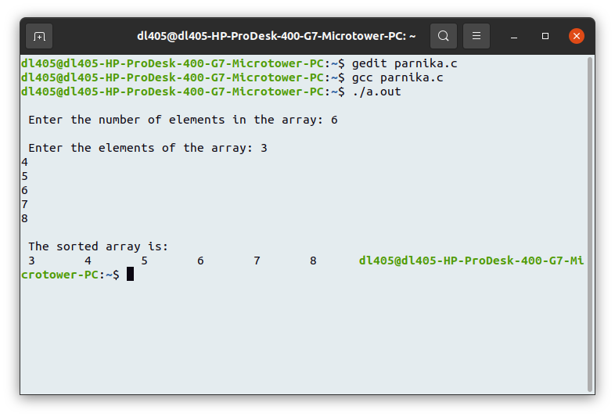

Conclusion:
By implementing Quick Sort in an e-commerce application, businesses can significantly enhance the customer experience by providing quick and efficient sorting of product listings. This not only improves user satisfaction but also can lead to increased sales as customers find it easier to navigate and discover products that meet their needs. Overall, choosing the right sorting algorithm, like Quick Sort, is essential for optimizing performance in real-world applications.

